Title: Template for Hbond2023: September 11 – September 15, 2023, Bologna
John A. Lemon¹, Mario D. Rossi², Paul C. Smith³
¹Institution, Country, emailaddress@xx.yy; ²Institution, Country, emailaddress@xx.yy; ³Institution, Country, emailaddress@xx.yy

Replace the text in this template making sure to format your abstract exactly like this document (keep font (Times New Roman), size (12 for the main text; 14 for the title), margins and basic layout). Abstracts may include figures and tables; the maximum length is one single page (A4). All accepted abstracts will be published in the book of abstracts. The deadline for submission is May 15th 2023.
The abstract in docx format should be submitted via the registration form: https://eventi.unibo.it/hbond2023bologna/registration-form

- Changes to an abstract will not be permitted after uploading.
- The submission should be made by the presenting author.
- Maximum file size: 500 kB.

The title should not exceed 250 characters including spaces. Do not forget to include the details of each author.

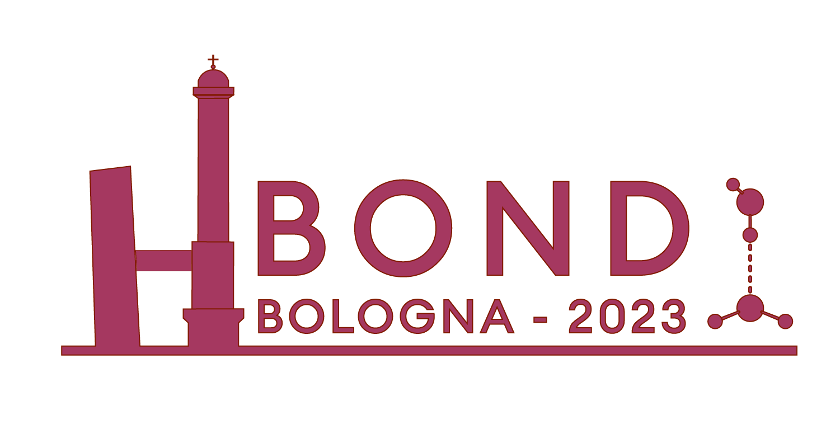
Fig. 1: The Hbond2023 logo.

Equations should be centered:
$$E_{k}=\frac{1}{2}{mv}^{2}$$

Use superscript Arabic numerals for references.¹

References
[1] R. M. Barrer, J.A. Davies, L.V.C. Rees, J Inorg. Nucl. Chem. 30, 3333, 1968

