RECRUITING DAY 2017
HOW TO ACCESS STUDENTS/GRADUATES CVs

From the page “area riservata alle aziende” of the website you can access the following links
CV REGISTERED STUDENTS/GRADUATES
Login with username and password (these are the same used to access the University of Bologna internship database tool es. nome.cognome@esterni.unibo.it & password)
Should you require new login details please register on https://aziende.unibo.it
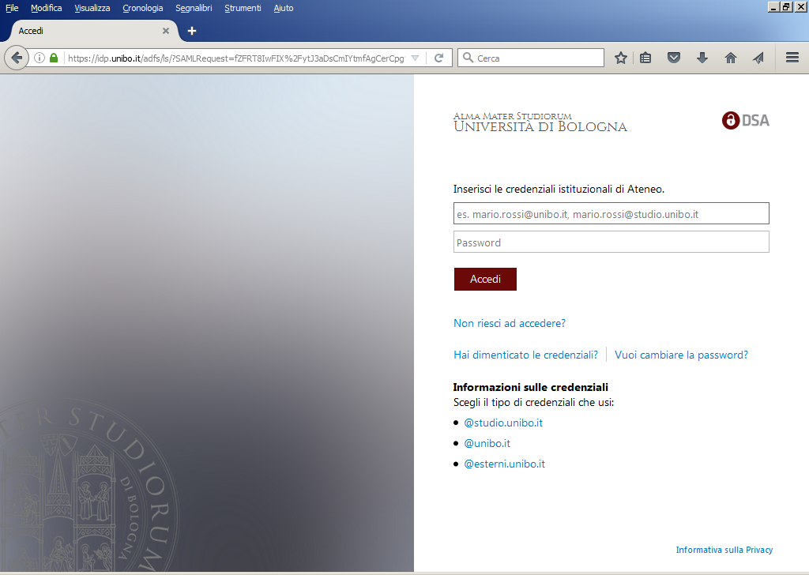

Once you are logged in, you can view the total number of participants registered to the event.
You can filter them using the dropdown menus to select the candidates who possess specific skills: i.e. type of degree, residence, degree course, graduation mark etc.
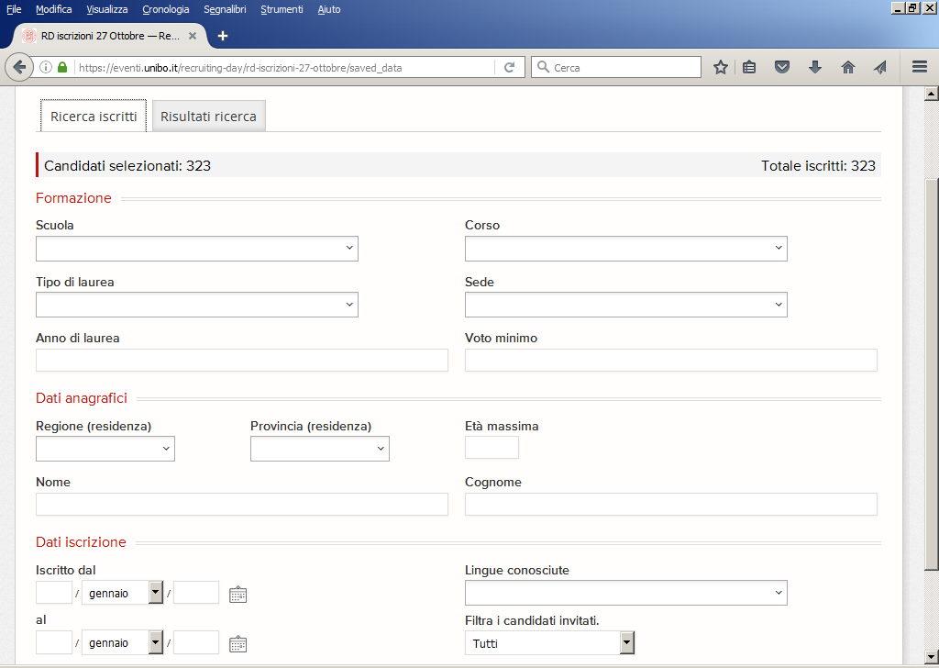
Select the candidates invited
Foreign Languages
Date of registration to the event
Age (no older than)
Graduation mark from…
Degree Date
Study Course Location
Degree Type
Degree Course
School
By clicking on the tab “RISULTATI RICERCA” you’ll view only those candidates who possess the requirements indicated in the filters. You can then choose to narrow down the search and invite only a few selected ones or invite all of them to your stand/desk.
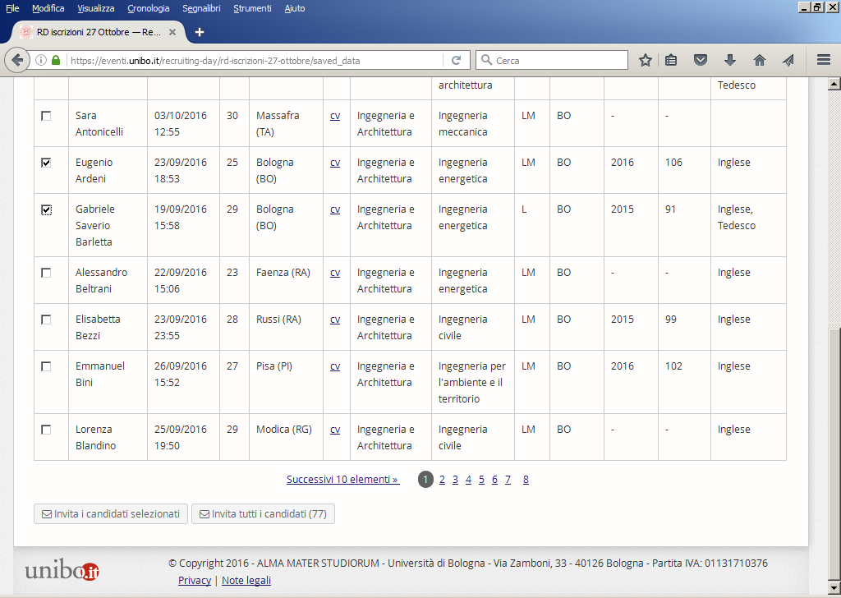
Invite all the filtered candidates
Invite the selected candidate only

The invitation email can be customised with a sender’s email (“noreply” is the standard setting), the sunject of the email and the email contents. It is also possible to send file attachments.
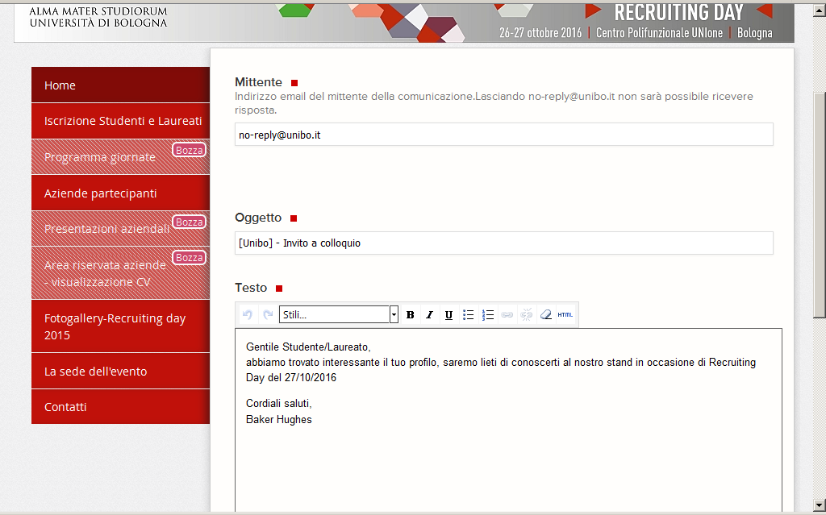
PLASE NOTE: on the search homepage it is always possible to view the list of sent items. 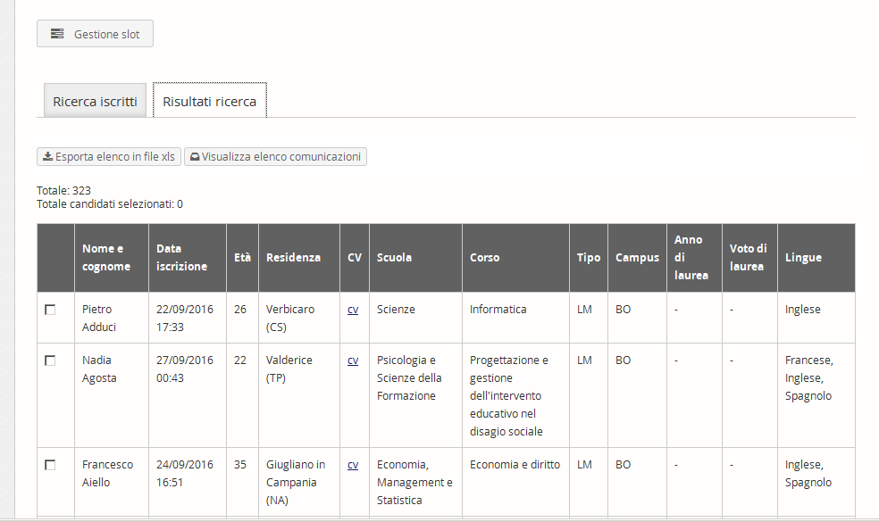
It is also possible to filter the candidates already invited and those who are yet to be invited.

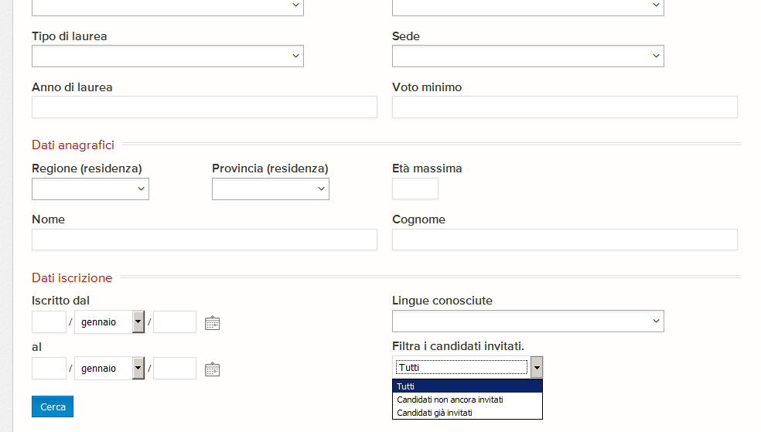
Invite all
Candidates not yet invited
Candidates already invited

For support please contact:
Jobplacement@unibo.it

